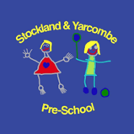**Newsletter: Friday 27th June 2025**

Dear Parents/Carers,

**Welcome**

What a wonderful week it’s been! The children have been full of enthusiasm as they’ve explored their learning environment with confidence and joy. It’s been fantastic to watch them immerse themselves in creative play, work together with friends, and take pride in their growing independence. From imaginative storytelling to hands-on discovery, this week has been full of exciting opportunities to learn, grow, and have fun.

**Little Gardeners, Big Discoveries: Planting, Growing, Tasting!**

This week brought a lovely moment of celebration in our garden as we harvested our very first strawberries! The children were thrilled to pick the bright red fruits they’ve been carefully tending and were even more excited to taste them. We also had the chance to nibble on some freshly picked peas—sweet and crunchy straight from the pod. Our tomato plants are beginning to grow too, and the children have loved spotting the tiny green tomatoes starting to appear. These hands-on experiences help build a deeper connection to nature and where our food comes from, while also encouraging curiosity and healthy eating habits.

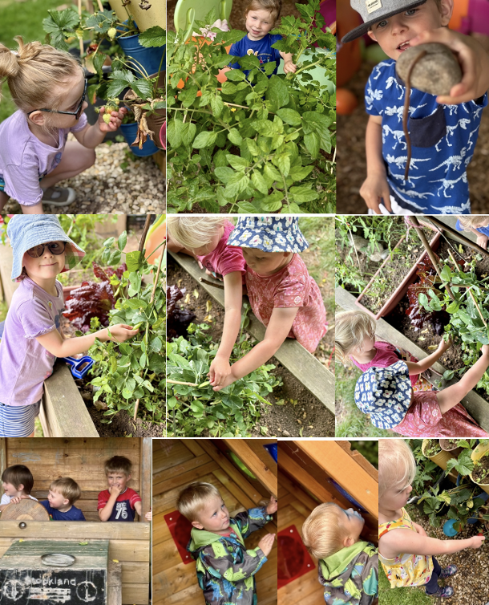

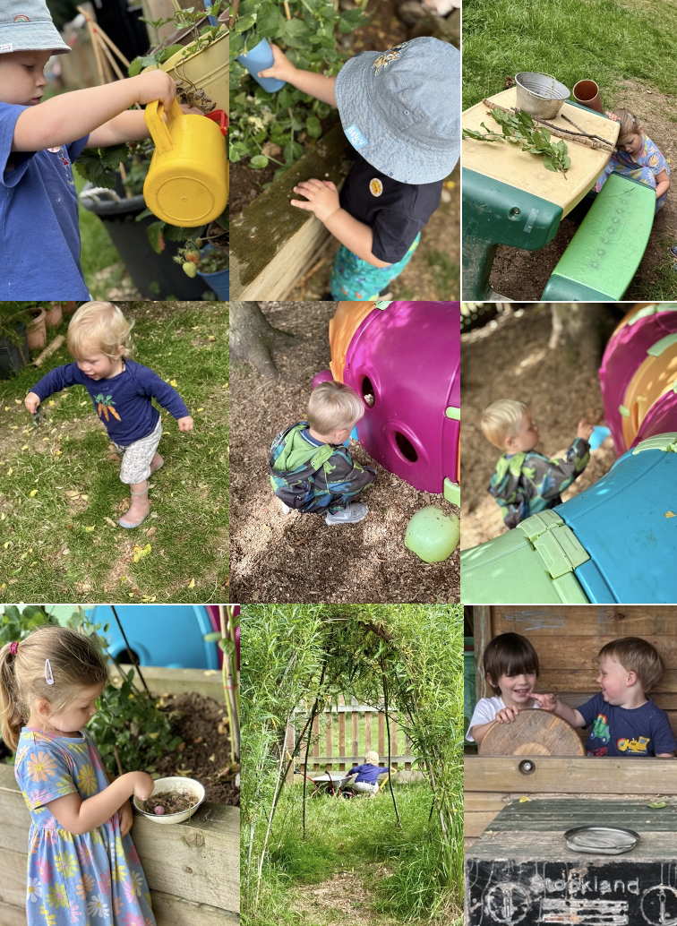

**Thursday Baking**

There was lots of excitement during our Thursday cookery session as the children got stuck into making their very own fruit ice lollies! They carefully selected pieces of fresh fruit and helped pour juice into moulds, developing fine motor skills and early understanding of healthy choices along the way. It was a refreshing and hands-on way to explore new tastes, practise turn-taking, and enjoy a sense of achievement—especially knowing they were going to try their frozen creations!

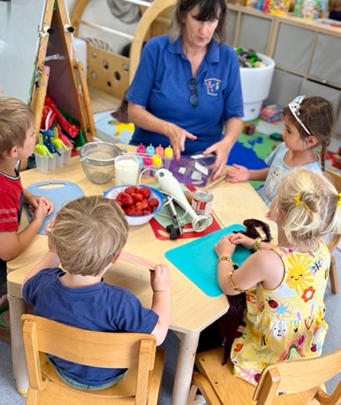 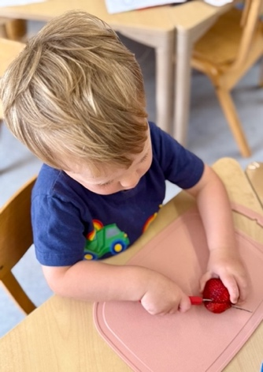 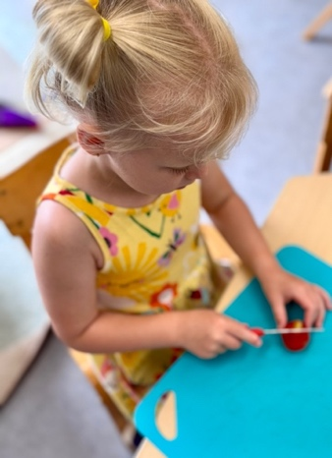

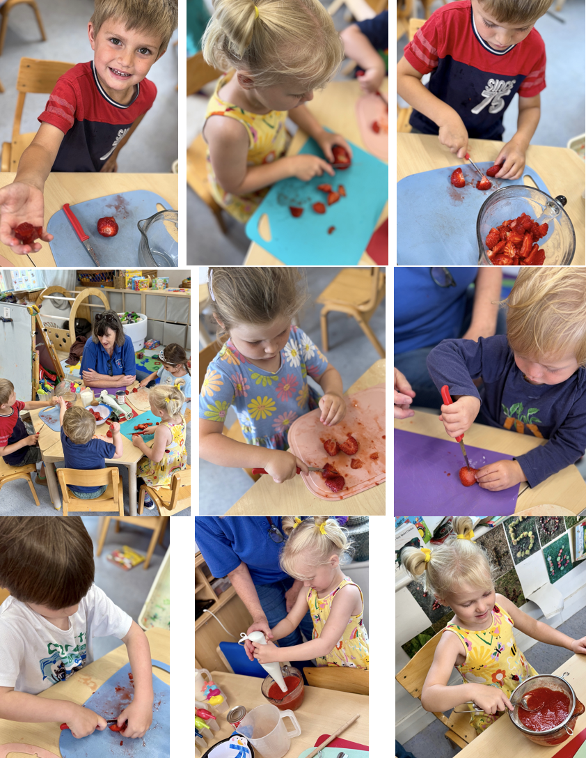

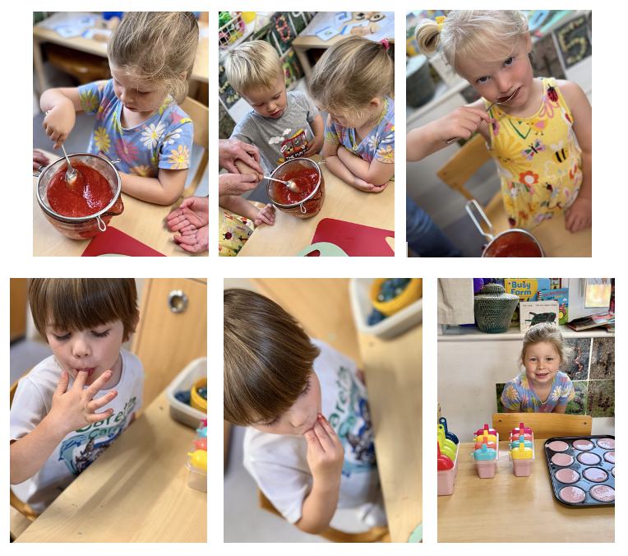

***Updates***

* **Reading**

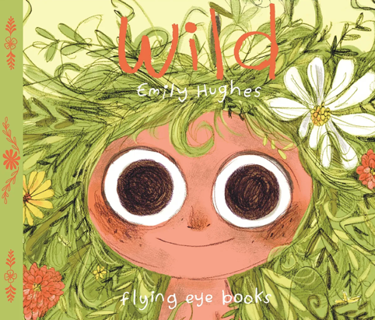In this beautiful picture book by Emily Hughes, we meet a little girl who has known nothing but nature from birth—she was taught to talk by birds, to eat by bears, and to play by foxes. She is unashamedly, irrefutably, irrepressibly wild. That is, until she is snared by some very strange animals that look oddly like her, but they don't talk right, eat right, or play correctly. She's puzzled by their behaviour and their insistence on living in these strange concrete structures: there's no green here, no animals, no trees, no rivers. Now she lives in the comfort of civilization. But will civilization get comfortable with her?

With our continuing focus on reading culture, we will keep recommending books to our families, with a view to trying to widen pupils' interest in different genres and authors.

* **🎒 Learning at home**

🎨 Creative Confidence

Make a “school storybook” together – draw pictures of what school might be like.

Use playdough to strengthen fingers for writing – squish, roll, and cut shapes.

🧩 Thinking & Problem Solving

Do simple jigsaw puzzles together to build concentration and spatial awareness.

Build towers or obstacle courses with blocks, boxes, or household items.

🗣️ Talking About Feelings

Use picture cards or books to talk about emotions and what helps when we feel worried or excited. Create a "feelings jar" where your child can choose how they’re feeling each morning.

***Reminders***

* **Mental Health:** At Pre-school, we focus on helping children feel safe, supported, and confident. As always, if you have any questions or would like ideas on how to support your child’s emotional development at home, please don’t hesitate to speak to a member of the team.
  + Helpful UK Resources for Families:
    - UNICEF UK Early Childhood Mental Health Toolkit [www.unicef.org.uk/campaign-with-us/early-moments-matter/early-childhood-mental-health-toolkit](http://www.unicef.org.uk/campaign-with-us/early-moments-matter/early-childhood-mental-health-toolkit)
    - NSPCC – Understanding Young Children’s Mental Health

<https://learning.nspcc.org.uk/child-health-development/child-mental-health>

* **Safeguarding:** At our setting, we regularly review our policies and training to ensure we are providing a safe, supportive, and inclusive environment for every child. If you ever have any questions or concerns about your child’s well-being, please speak to a member of our safeguarding team.

The Safer Internet Centre has some excellent advice in their Parents’ guide to Technology and includes device specific settings for different models: [www.saferinternet.org.uk/advice-centre/parents-and-carers/parents-guide-technology](http://www.saferinternet.org.uk/advice-centre/parents-and-carers/parents-guide-technology)

*Please see previous newsletters on the website for further links to mental health support, safeguarding and online safety, as well as school readiness.*

**Timetable**

Exploring Different Cultures in Pre-School – Handa’s Surprise

As part of our learning through the EYFS framework, we regularly explore and celebrate different cultures, traditions, and ways of life to help children develop a strong sense of understanding, respect, and belonging here in our Pre-School community. Whether through stories, music, food, celebrations, or creative projects, we gently introduce the children to both the similarities and differences that make people and places unique. These rich experiences support not only their personal, social, and emotional development, but also help nurture key values such as kindness, curiosity, and inclusion—all of which are central to our day-to-day practice. Next week, we’re using Handa’s Surprise by Eileen Browne as a key text to support this learning. Set in a Kenyan village, the story opens a window into a different culture and environment, sparking conversations about life in other parts of the world. Building on our recent work with Supertato and Oliver’s Vegetables, Handa’s Surprise also continues our exploration of healthy eating, introducing the children to a colourful range of fruits from around the world, and providing opportunities to talk about animals, habitats, and sharing. In Pre-School, we’ll be exploring this story through storytelling, role play, small-world activities, fruit tasting, and creative projects. The book’s rhythmic language and vivid illustrations will support children’s early literacy skills such as recall, sequencing, and vocabulary, while also offering a joyful way to explore the world beyond our classroom.

Make It Monday:

* Phonics – Daily

Phonics is taught daily using the Read Write Inc. programme to support children in developing early reading and writing skills. Children learn the Set 1 Speed Sounds, focusing on individual letter sounds and blending them to read simple CVC (consonant-vowel-consonant) words such as *cat*, *dog*, and *sun*. Alongside this, they practise forming letters, with a particular focus on writing the special letters in their own names, helping to build confidence and strengthen early handwriting skills.

* Maths - daily - As part of our ongoing learning through stories, your child will be taking part in a *Handa’s Surprise* themed maths session throughout the week. The activities will take place indoors and outdoors. The children will explore numbers, patterns, size, and sorting — all through fun, fruit-filled activities based on the characters and events in the story.

What Your Child Will Be Doing:

1. Counting Fruits

* Your child will count out the fruits from *Handa’s Surprise*, using real fruits, toys, or pictures.
* They will practise counting up to 8 and use simple subtraction when animals “take” the fruits away.

2. Matching Numbers

* The children will match number cards (1–8) with the correct number of fruits.
* They will use one-to-one correspondence to place the right amount with each number.

3. Sorting and Grouping

* Your child will sort fruits by type, colour, or size.
* They will group similar fruits together and explain how they made their choices.

4. Ordering by Size

* The children will compare fruits and place them in size order, from smallest to largest.
* They will use language like “bigger,” “smaller,” “heavier,” and “lighter.”

5. Making Fruit Patterns

* Your child will create repeating patterns using fruits or coloured counters (e.g., banana-orange-banana-orange).
* They will be encouraged to continue and make their own patterns.

If you'd like to extend the learning at home, you could count fruits during snack time, sort toys by colour or size, or retell *Handa’s Surprise* with your child using fruit from the kitchen!

Tinkering Tuesday:

* Phonics.
* Maths
* 🧺 **Storytelling & Literacy:** We will create a **story basket** with the fruits and animals from Handa’s Surprise, encouraging the children to retell the story using props. The children will also use **sequencing cards** to order the events of the story, helping them develop early storytelling and vocabulary skills. We will play a **“name the fruit”** game to practise recognising fruit names, colours, and initial sounds.
* 🎨 **Creative Arts:** The children will make their own **paper head baskets** like Handa’s and practise balancing them in movement play. They will also create a **fruit collage,** cutting and sticking different fruits into a basket shape.
* 🎵 **Music & Movement:** We will introduce the children to **African drumming and rhythms**, listening to traditional music and experimenting with instruments. They will also take part in a **movement session**, moving like the animals from the story—leaping like goats, stomping like elephants, and slithering like snakes.

Welly Walk Wednesday, Sports Day & Transition to school:

* Sports Day
* Phonics
* Maths
* 🗣️ **Personal, Social and Emotional Development:** We will have discussions about **kindness and friendship,** using Handa’s actions as a starting point. The children will be encouraged to think about ways they can surprise or help others. We will also set up a **role play corner** inspired by the story for imaginative market or home play.

Thinking Thursday:

* Phonics
* Maths
* Thursday baking session: As part of our learning around Handa’s Surprise, the children will take part in a special baking session where we’ll be making fruit muffins inspired by the delicious fruits in the story. Using ingredients like banana, mango, and pineapple, the children will have the opportunity to smell, touch, and taste the fruits before helping to mix and spoon the batter into cases. This hands-on activity not only supports their fine motor skills and early maths through measuring and counting, but also brings the story to life in a fun and meaningful way. We can’t wait to see (and taste!) the children’s fruity creations.

Fresh Air Friday:

* Phonics
* Maths
* 🥭Story Walk and Fruit Trail: The children will listen to *Handa’s Surprise* as we walk through the forest. They will stop at stations featuring different fruits and animals from the story. They will act out scenes and talk about what happens as Handa walks to her friend’s village.
* 🧺Basket-Balancing Game: Your child will try to carry a basket (or bowl) on their head like Handa. They will develop balance and coordination through playful movement.
* 🐒Animal Hunt: The children will search the forest for toy animals or pictures linked to the story. They will match the animals to the fruits they took and recall parts of the story.
* 🍂Natural Basket Making:The children will use natural materials to create their own small “baskets.” They will collect natural items to fill them—encouraging teamwork and creativity.
* 🎭Story Retelling with Nature: Your child will use sticks, leaves, and stones to recreate characters or scenes. This helps with memory, imagination, and connecting the story to their environment.

**Dates for the Diary**

* Transition to Stockland Primary Academy:Wednesday afternoons 1.30 - 2.30pm; Wednesday 4th June and continuing until the last one on Wednesday 16th July.
* **🏃‍♀️🏅** Sports Day: Wednesday 2nd July 2025,9.30 – 10.00AM @ the primary school playing field (weather permitting).
* Parent Consultations: Monday 7th July 2025 and Thursday 10th July 2025.
* Pre-School Trip: Monday 21st July 2025 - Foxdown Children's Farm, 10am - 2pm.
* Last Day of Summer Term: Tuesday 22nd July 2025.

**Contact Details**

Stockland Victory Hall, Stockland, Devon EX14 9EF. Phone: 01404 881450

[info@stocklandpreschool.co.uk](mailto:info@stocklandpreschool.co.uk)

**Safeguarding**

If you have any safeguarding concerns, please email [jemma@stocklandpreschool.co.uk](mailto:jemma@stocklandpreschool.co.uk). This inbox is monitored daily. Our Designated Safeguarding Lead is Jemma Harvey-Jones and our Deputy Designated Safeguarding Leads are Kelly Patch and Alice Hutter. Our Child Protection and Safeguarding Policy can be found online at: <https://stocklandpreschool.co.uk/policies-and-procedures/safeguarding>. If you have any concerns about the safety of a child you can either talk to our DSL or DDSL or you can phone Devon MASH on 01392 384964.

**CORE COMMITTEE**

Christina Leppard - Committee Chair [chair@stocklandpreschool.co.uk](mailto:chair@stocklandpreschool.co.uk)

Pippa Salter – Vice Chair, Secretary and Safeguarding [vicechair@stocklandpreschool.co.uk](mailto:vicechair@stocklandpreschool.co.uk)

Emily Foxwell – Treasurer [treasurer@stocklandpreschool.co.uk](mailto:treasurer@stocklandpreschool.co.uk)

**STAFF**

Jemma Harvey-Jones – Manager, SENDCo and DSL [jemma@stocklandpreschool.co.uk](mailto:jemma@stocklandpreschool.co.uk)

Sam Steward - Deputy Manager [sam.s@stocklandpreschool.co.uk](mailto:sam.s@stocklandpreschool.co.uk)

Kelly Patch - Deputy Safeguarding Lead [kelly.p@stocklandpreschool.co.uk](mailto:kelly.p@stocklandpreschool.co.uk)

*To contact any other members of our team please email the* [*info@stocklandpreschool.co.uk*](mailto:info@stocklandpreschool.co.uk) *account and your queries will be forwarded appropriately.*