

Newsletter: Friday 20th June 2025

Dear Parents/Carers,

Welcome

Another busy and exciting week has come to a close! The children have been confidently exploring all areas of the classroom, making independent choices and engaging with a wide range of hands-on activities. It’s been lovely to see their curiosity and creativity shine as they take on new challenges. This week, we focused on a variety of fun and enriching experiences.

Thank you

A big thank you to all the parents and carers who kindly donated resources to support our Supertato-themed learning this week. The children had so much fun exploring vegetables, creating their own superhero characters, and diving into the world of Supertato! Your generosity helped bring the story to life and made our activities even more engaging and memorable. We truly appreciate your continued support.

Writing Names – A Gentle and Supportive Approach

The children have been practising how to write their names — showing great concentration and pride in their efforts. At this stage, we understand that children learn in different ways and at different times. We begin encouraging them to hold a pencil using the ‘tripod’ grip and to have a go at writing their names as soon as they show confidence and readiness. Our approach is always gentle and supportive, making sure each child builds these early writing skills at their own pace, in a way that feels positive and successful for them.

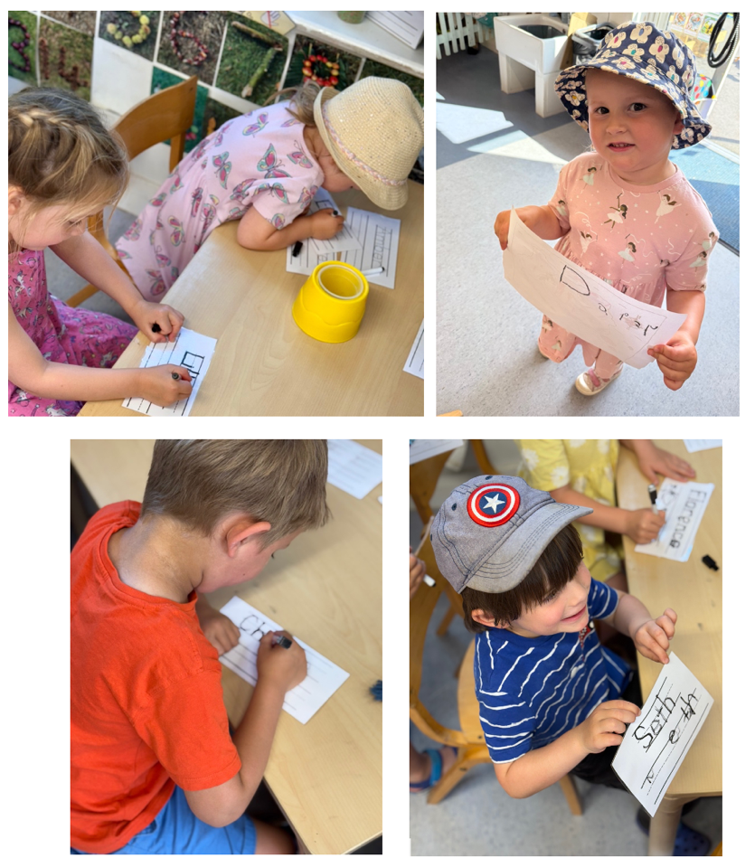

Creative Fun

In our creative area, the children enjoyed vegetable printing with paint, exploring patterns, shapes, and textures in a colourful way. We also had lots of imaginative fun turning vegetables into superheroes, giving each one special powers and personalities!

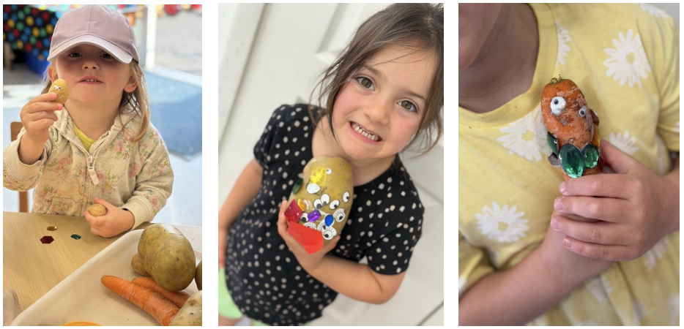

Thursday Baking

There was lots of excitement during our Thursday cookery session too, as the children made their own fruit kebabs, developing fine motor skills while learning about healthy food choices.

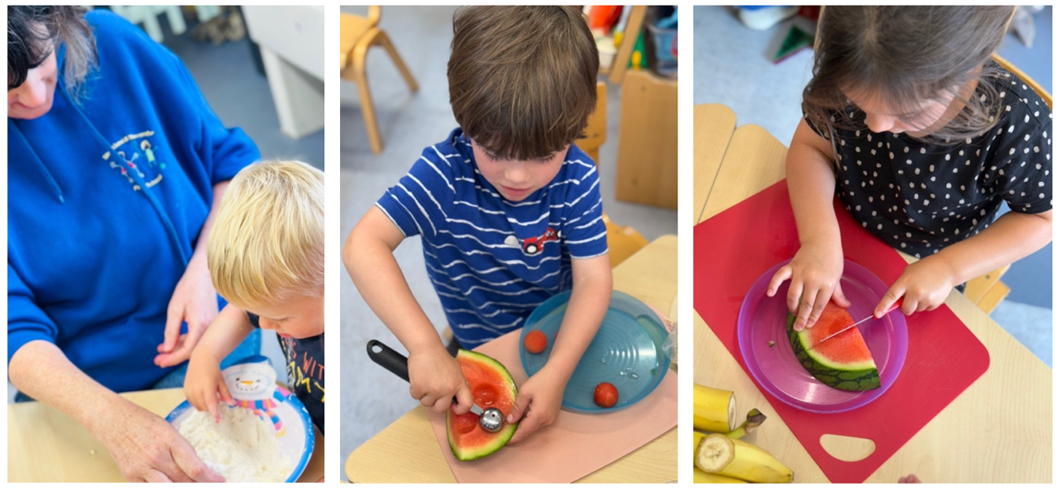

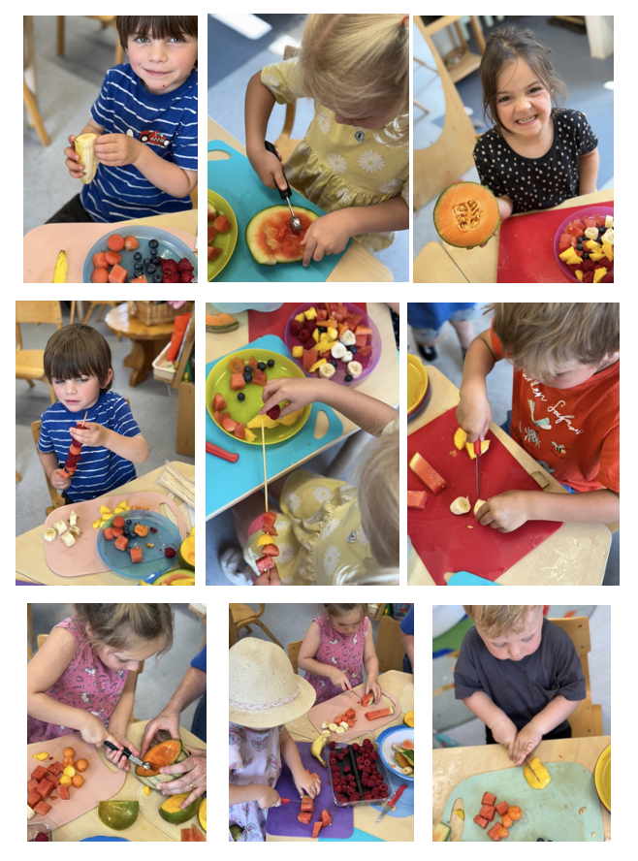

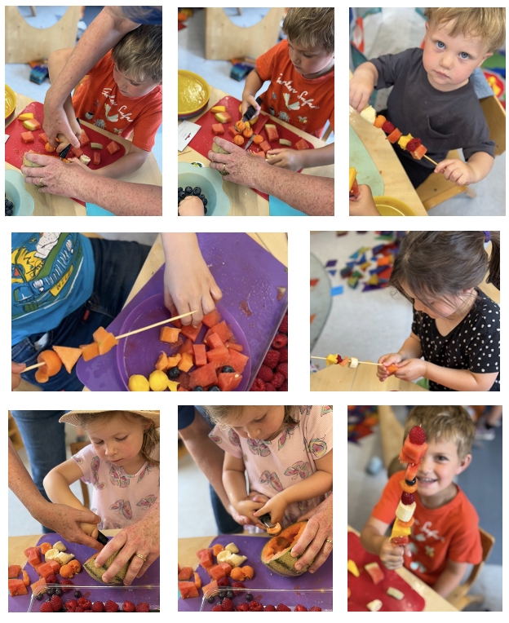

Making Potions

To top it all off, the children created magical fruit and water potions, combining different ingredients to make their own imaginative mixtures—full of colour, scent, and a touch of preschool magic.

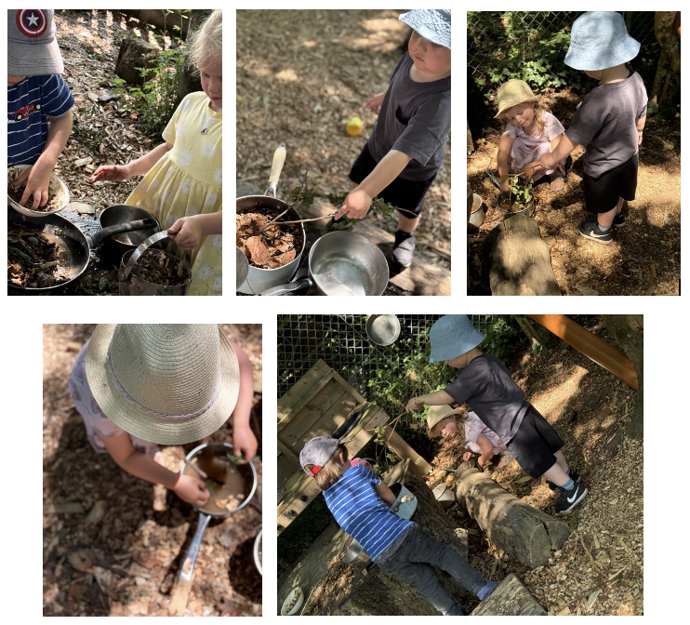

Fun, Fun, Fun!

As you can see, we’ve had a joyful week of learning through play and creativity. We’re so proud of everything the children have explored and achieved!

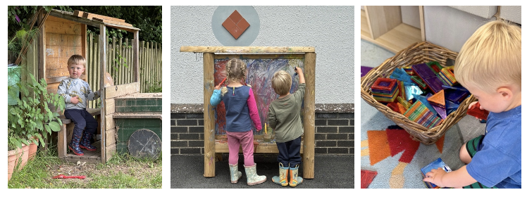

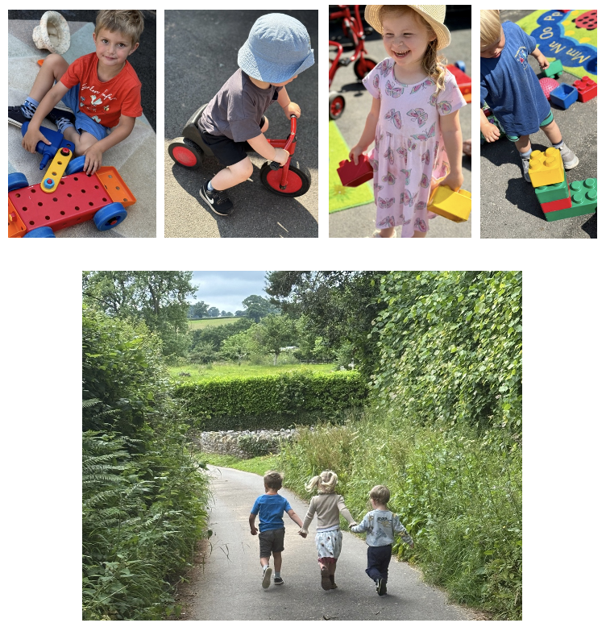

Committee

Pre-School is lucky to have a committee who meet once a half-term to discuss issues arising with the setting. The committee also arrange fund-raising events each half term that enable us to purchase resources for all the children to enjoy. Some resources are consumables and we do need to refill certain areas each half term. Other resources are permanent and do need extra funds. Stockland and Yarcombe Pre-School is a charity and we can only operate if we have enough volunteers and people who are happy to become trustees. Our present committee have many members whose children will be going to school in September. Please let me know if you can support us and join our committee, it isn’t too late. Particularly parents of our younger children. It is good fun and a great way to meet friends. Please forward any interest verbally or via email.

Catching Up

Just a quick reminder — if I’m not at the gate during morning drop-off, please don’t hesitate to ask a member of staff, and I’ll be happy to come out and have a quick chat. There may be times when I’m supporting children inside at the start of the day, but I’m always happy to connect when needed. Please remember that if you have any questions or concerns, your child’s key worker is always your first port of call, and you’re also very welcome to speak to one of our Deputy Designated Safeguarding Officers – Kelly, Alice or Sam – who are always happy to help and support. Thank you for your understanding and continued support.

Updates

- Reading

The Hargraves want their new baby to grow up big and strong. But the puny mite will hardly eat a thing. One day Mrs Hargraves finds an avocado in the fruit bowl and the baby gobbles it up. Soon, the strangest things start to happen... With our continuing focus on reading culture, we will keep recommending books to our families, with a view to trying to widen pupils' interest in different genres and authors.
- 🎒 Learning at home when it’s Hot, Hot, Hot!
Learning through play not only develops the child’s skills with mathematics, literacy, communication and language, it is vital in the development of their imagination, creativity, emotional regulation, resilience, wellbeing, and sharing skills. Here are a few ideas of how your child can learn while enjoying heaps of fun at home.
  - Water fun with a paint brush (any size) and container of water: On a hot day get the children to ‘paint’ on an outside wall , fence or the path. They will see their mark making magically disappear as the heat evaporates their masterpieces. How high can they reach up to paint?
  - What next? Give them the responsibility to clean items in the garden; patio furniture, the swing/slide, plant pots, the choice is endless. Again using just an old brush and pot of water. Congratulate them on their hard work .
  - More fun… Place objects on the ground and water paint around them. What shape has been made? Even lie on the ground yourself and let them paint around you. Then you have your turn and paint around them.
  - And now? A small watering can or jug to help water the plants. Talk about the shapes and colours they can see. Why do plants need water ? Are there any minibeasts hiding….endless questions and opportunities to explore.
  - Finally… Wash the car, bikes, scooters etc. Anything that involves suds and water is energising and fun. Give them a washing up bowl to wash their own toys. Is their toy car the same as your car, how many toys have they washed ? Do they float or sink?

Reminders

- Sports Day: Please let us know if your child will be joining us for Sports Day but is not normally in attendance, by Monday 23rd June 2025.
- Mental Health: At Pre-school, we focus on helping children feel safe, supported, and confident. As always, if you have any questions or would like ideas on how to support your child’s emotional development at home, please don’t hesitate to speak to a member of the team.
  - Helpful UK Resources for Families:
    - UNICEF UK Early Childhood Mental Health Toolkit www.unicef.org.uk/campaign-with-us/early-moments-matter/early-childhood-mental-health-toolkit
    - NSPCC – Understanding Young Children’s Mental Health
https://learning.nspcc.org.uk/child-health-development/child-mental-health
- Safeguarding: At our setting, we regularly review our policies and training to ensure we are providing a safe, supportive, and inclusive environment for every child. If you ever have any questions or concerns about your child’s well-being, please speak to a member of our safeguarding team.
The Safer Internet Centre has some excellent advice in their Parents’ guide to Technology and includes device specific settings for different models: www.saferinternet.org.uk/advice-centre/parents-and-carers/parents-guide-technology
Please see previous newsletters on the website for further links to mental health support, safeguarding and online safety, as well as school readiness.

Timetable

Next week, we will be exploring the delightful story ‘Oliver’s Vegetables by Vivian French’. We will talk about where vegetables come from and how they grow. Your child will learn to identify different vegetables. We will support language development, creativity, and fine motor skills through themed activities! This engaging book will help us learn about healthy eating, gardening, and trying new things. Here's a look at what your child will be doing during the week:

Make It Monday:
- Phonics.
- Story & Vegetable Talk:
  - We will read Oliver’s Vegetables together.
  - Children will share what vegetables they already know.
  - We will play a vegetable sorting game and sing a fun food-themed song.

Tinkering Tuesday:
- Phonics.
- Today, we will re-read Oliver’s Vegetables and talk about how Oliver was brave enough to try new foods. Inspired by the story, the children will have the chance to taste a variety of vegetables and discuss their favourites. We will then create a fun veggie chart together to show what everyone enjoyed most! To help make this activity a success, we would really appreciate any donations of fresh vegetables—big or small! Popular options include carrots, cucumber, cherry tomatoes, peppers, sugar snap peas, or anything your child might like to share. Please bring any donations by Monday morning, if possible, but we will welcome them anytime!

Welly Walk Wednesday, PE with Mr Murnane & Transition to school:
- Phonics
- We will learn the names of new vegetables and match pictures to their names.

Thinking Thursday:
- Phonics
- Thursday baking session: In next Thursday’s baking session, the children will be making their very own homemade ice lollies using a mix of fresh fruits and natural juices. This fun, hands-on activity is a great way to explore healthy ingredients while keeping cool as summer approaches. The children will have the chance to chop, mix, and pour, creating colourful and tasty treats to enjoy together!
Fresh Air Friday:
- Phonics
- The children will go on a vegetable treasure hunt, dig for root vegetables, and create their own pretend gardens using natural materials. They will also have the chance to make mud kitchen “vegetable soup,” explore herbs and vegetables with their senses, and use vegetables to create prints on bark or paper. These activities will help support their understanding of where food comes from, encourage imaginative play, and connect their learning to nature in fun, meaningful ways.

How You Can Support at Home:

- Try some vegetable tasting at home and talk about which ones your child likes.
- Read Oliver’s Vegetables (or similar books) together.
- Involve your child in simple cooking or planting activities if possible.

Thank you for your continued support. We’re excited for a week full of learning, growing, and healthy fun!

Dates for the Diary

- Transition to Stockland Primary Academy: Wednesday afternoons 1.30 - 2.30pm; Wednesday 4th June and continuing until the last one on Wednesday 16th July.
- 🏃‍♀️🏅 Sports Day: Wednesday 2nd July 2025, 9.30 – 10.00AM @ the primary school playing field (weather permitting). Please let us know if your child will be joining us but is not normally in attendance by Monday 23rd June 2025.
- INSET Day – Pre-School Closed: Friday 27th June 2025.
- Parent Consultations: Monday 7th July 2025 and Thursday 10th July 2025.
- Pre-School Trip: Monday 21st July 2025 - Foxdown Children's Farm, 10am - 2pm.
- Last Day of Summer Term: Tuesday 22nd July 2025.

Contact Details

Stockland Victory Hall, Stockland, Devon EX14 9EF. Phone: 01404 881450
info@stocklandpreschool.co.uk

Safeguarding

If you have any safeguarding concerns, please email jemma@stocklandpreschool.co.uk. This inbox is monitored daily. Our Designated Safeguarding Lead is Jemma Harvey-Jones and our Deputy Designated Safeguarding Leads are Kelly Patch and Alice Hutter. Our Child Protection and Safeguarding Policy can be found online at: https://stocklandpreschool.co.uk/policies-and-procedures/safeguarding. If you have any concerns about the safety of a child you can either talk to our DSL or DDSL or you can phone Devon MASH on 01392 384964.

CORE COMMITTEE

Christina Leppard - Committee Chair chair@stocklandpreschool.co.uk
Pippa Salter – Vice Chair, Secretary and Safeguarding vicechair@stocklandpreschool.co.uk
Emily Foxwell – Treasurer treasurer@stocklandpreschool.co.uk

STAFF

Jemma Harvey-Jones – Manager, SENDCo and DSL jemma@stocklandpreschool.co.uk
Sam Steward - Deputy Manager sam.s@stocklandpreschool.co.uk
Kelly Patch - Deputy Safeguarding Lead kelly.p@stocklandpreschool.co.uk

To contact any other members of our team please email the info@stocklandpreschool.co.uk account and your queries will be forwarded appropriately.

