**Newsletter: Friday 31st January 2025**

Dear Parents/Carers,

We start this week by welcoming 3 new members (our first 3 under-twos) to our Pre-school family! We would like to say a very big ‘well done’ to the tremendous three who have been busy investigating their new environment.

You may have noticed that there have been quite a few changes to our setting in recent weeks.… Lots of changing around of furniture to open up the space, moving of toys and equipment to create ‘zones’, together with newly purchased resources. The children deserve big ‘congratulations’ for coping with all the changes, as well as a ‘thank you’ for their help in building shelving with us. One of our exciting deliveries included lots of new paints. The children couldn’t wait to get their hands on these and have enjoyed experimenting making new colours using primary colours, plus black and white. Before they started mixing, we used multi-coloured Perspex blocks to see what colours could be made when looking through the two or three different colours. They then got busy discovering that blue and yellow make green; and red and yellow make orange together with an array of many different colours and shades.

A further thank you to those parents who donated some beautiful books, games and toys last week.

***Update***

* 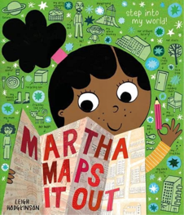Reading: Book Recommendations - *Martha Maps It Out by Leigh Hodgkinson.*

With our continuing focus on reading culture in school, we will continue to recommend books to our families, with a view to trying to widen pupils' interest in different genres and authors, supporting parents to know new authors and as ideas for gifts. If you share one of these books with your child in the future, we would love to hear from you. Let us know what you and your child/children thought of the book and we can share it on Facebook.

* You may have noticed that the newsletters are uploaded to the website weekly at: <https://stocklandpreschool.co.uk/general-information>. From next week we will no longer be emailing a copy to you but you will find it on the above link, each Friday afternoon.
* We believe Mental Health and Wellbeing is how we feel, think and act. It determines how we handle stress, manage relationships and make choices. It is important to all of us, at every stage of our lives, from childhood through to adulthood. The following resources/ organisations are used within preschool/school but can also be used at home too for support regarding Mental Health and Wellbeing:
  + Young Minds - www.youngminds.org.uk is the UKs leading child and adolescent mental health charity. The information for parents is especially good.
  + Thinkuknow - www.thinkuknow.co.uk is the education programme from NCA-CEOP, a UK organisation that protects children online. The parent /carer section has advice, tips and guides about how to keep children safe online.
  + Childline - www.childline.org.uk 0800 11 11 this website has tips and advice on how to deal with worries and activities to do if you are feeling anxious.

If you are concerned about any wellbeing issues, please don’t hesitate to get in contact with us at here at pre-school.

* Safeguarding Information: Keeping under-fives safe online.

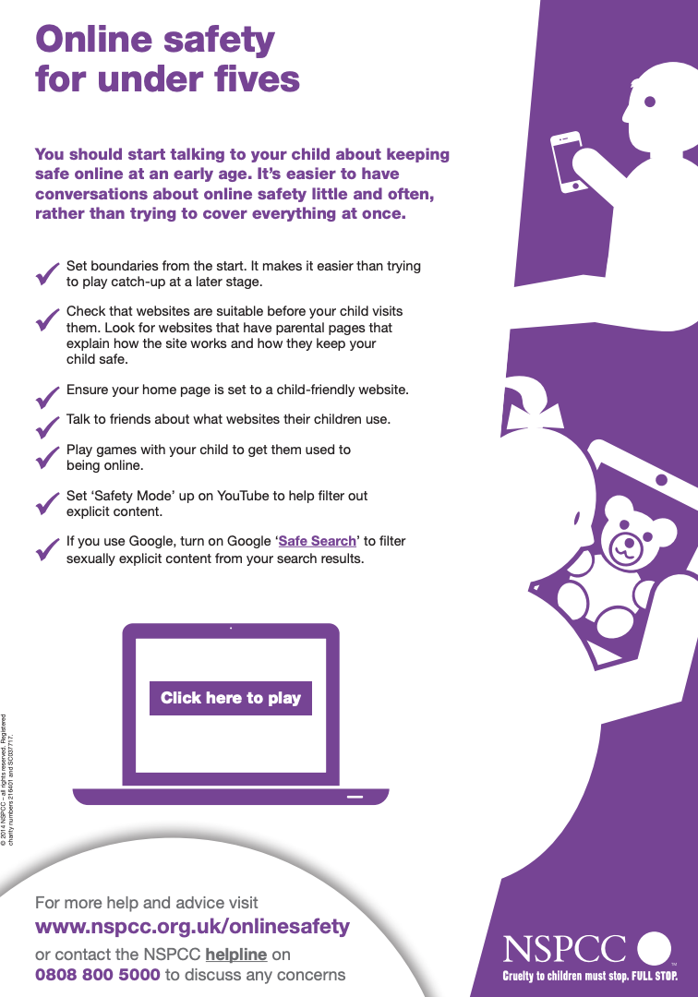

***Reminders***

* We are now accepting children from 18 months old; we would be grateful to you continuing to share this fantastic news with any parents/carers that you think may be interested in accessing this provision.
* Breakfast Club now runs Monday – Friday, 8.00 – 8.40. Please do get in touch should you wish to use our wraparound care.
* If your child attends After School Club, please send them with an additional snack. Thank you.
* Next week is Children's Mental Health Week (3 - 9 February 2025). We will all be taking part in mental health activities at various times through the week. You can get involved at home too. Place2Be is a children's mental health charity and their theme this year is ‘Know Yourself, Grow Yourself’. It’s about equipping and empowering children, young people, and the adults who surround them to embrace self-awareness and explore what it means to them. You can download the resources to use at home here:

[www.childrensmentalhealthweek.org.uk](http://www.childrensmentalhealthweek.org.uk)

* We are outside a lot and sometimes we get rather messy at preschool when using resources such as paint and water as part of our learning. Please can you ensure that your child/ren have plenty of warm, spare clothes in their bags as the weather gets even wetter and muddier, so that we can keep them clean and warm!
* For those of you with a child/ren leaving us at the end of the year, getting your child ready for starting primary school can feel like a big step, so it’s understandable if you’re feeling nervous about this new chapter in their life. You’re not the only one, and it’s likely that your child will be feeling a mix of emotions too. You may find some useful resources on this website: <https://healthforunder5s.co.uk/preschool/?cat=ready-for-school>, including videos and resources such as articles that highlight things you can work on at home to help your child develop the skills they need for school and a reward chart to support this.
* Partnership with Parents: No one knows your child better than you, so our partnership with parents is integral to our way of working. We look forward to talking with you in our termly parents’ meetings/telephone consultations; our aim is to ensure you have the time to discuss your child’s individual needs and progress with their appointed key person. However, our ‘open-door’ policy means that parents are welcome to come and speak to us at any time. We promote home learning, and encourage parents to participate and contribute to their child’s development, sharing information on a daily basis through Tapestry and face-to-face.
* Please do remember that I welcome any suggestions that you may have with regards to improving our offer. For example, is there anything that you would like to see us doing which currently is not in place? How do the hours suit your needs? I am keen to ensure that we support our families with the best provision possible.

***Snaps***

*Goldilocks and The Three Bears*

*Just look at the concentration on these little faces!*

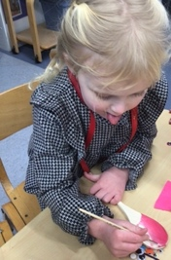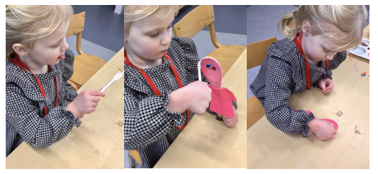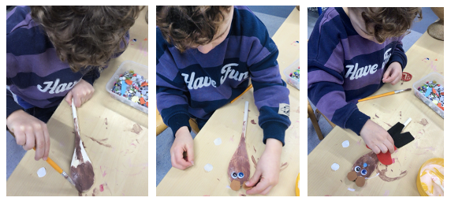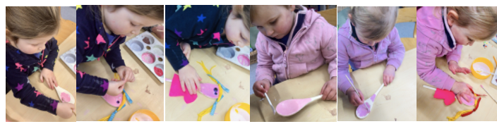

*When you are twins - so you need to make baby bear a twin too!*

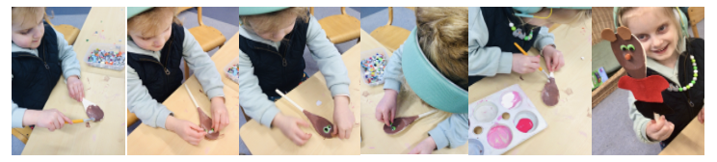

*Jumping and Travelling in PE*

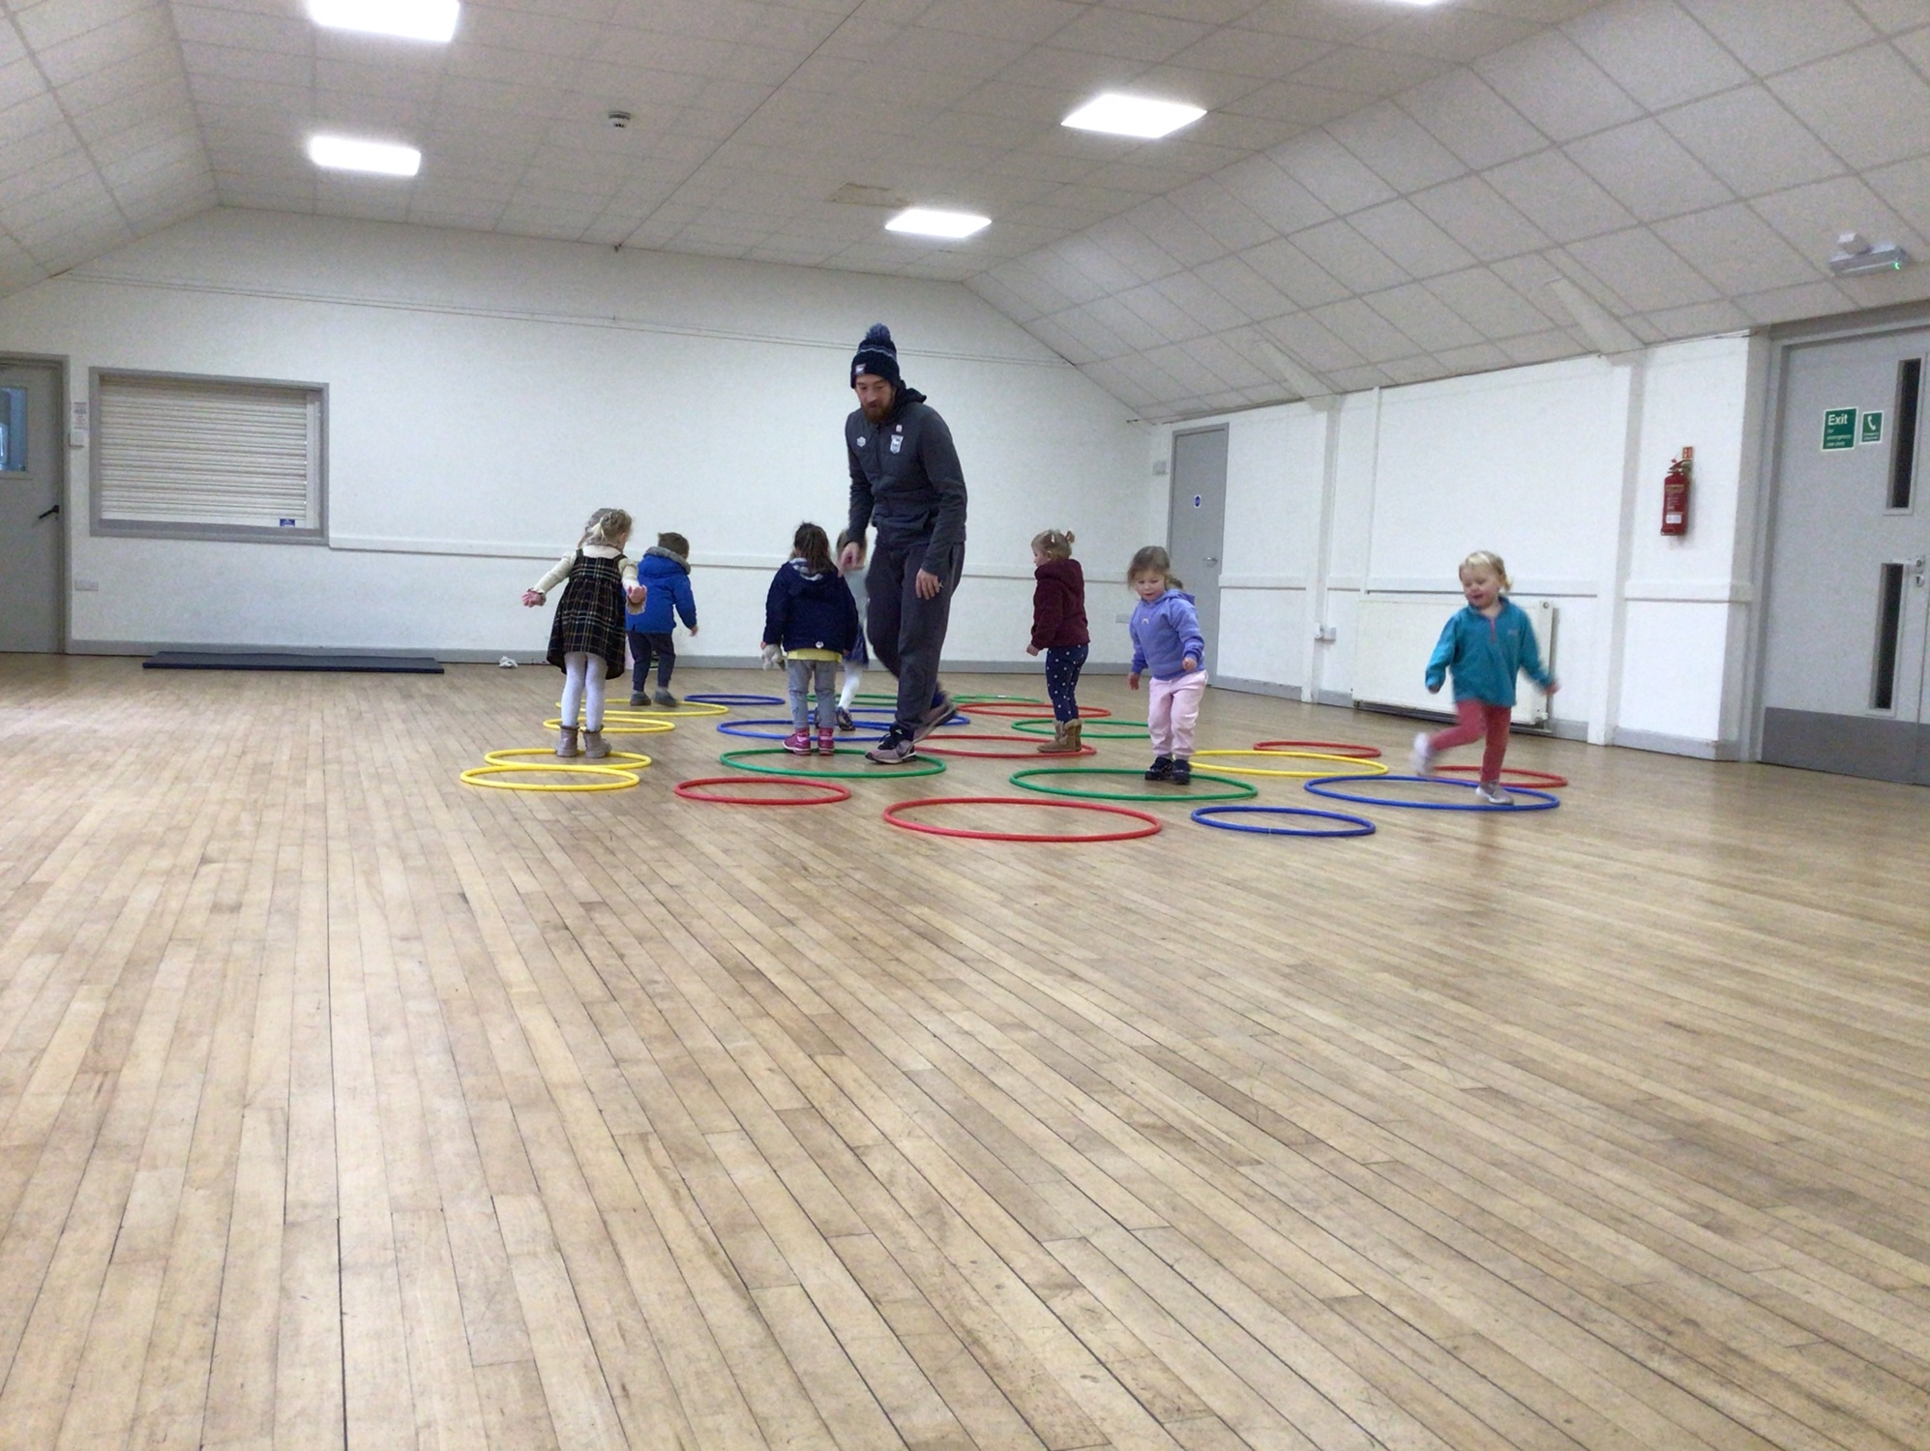

*Baking ‘Goldie Flapjacks’*

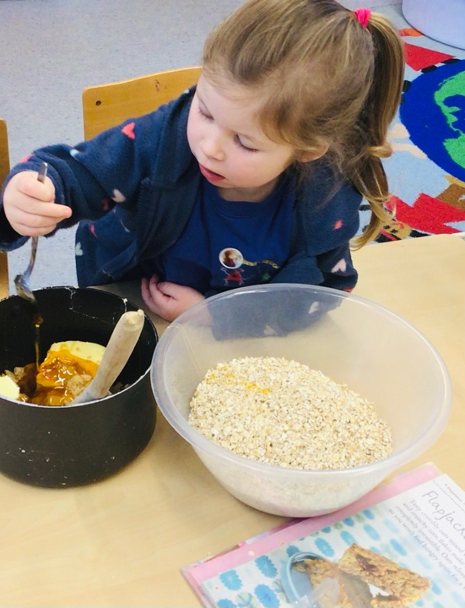 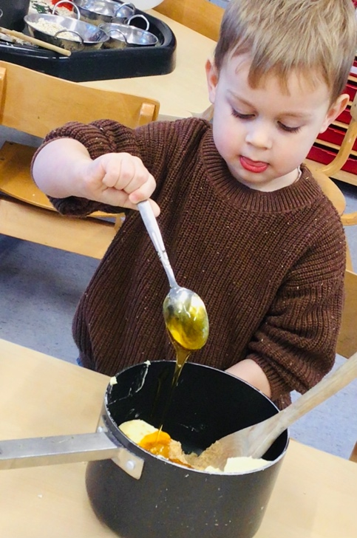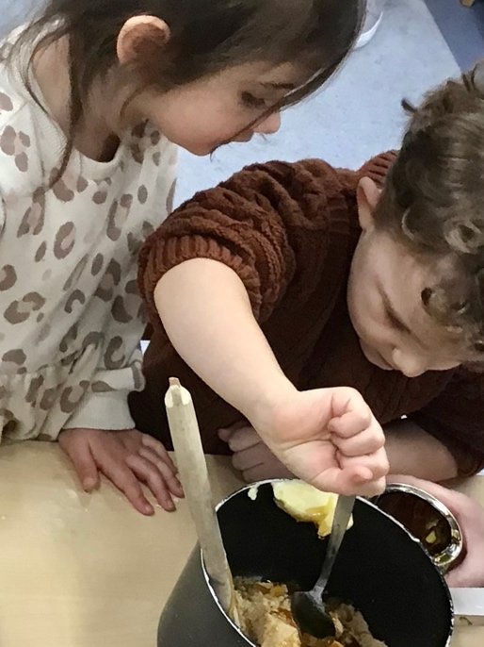 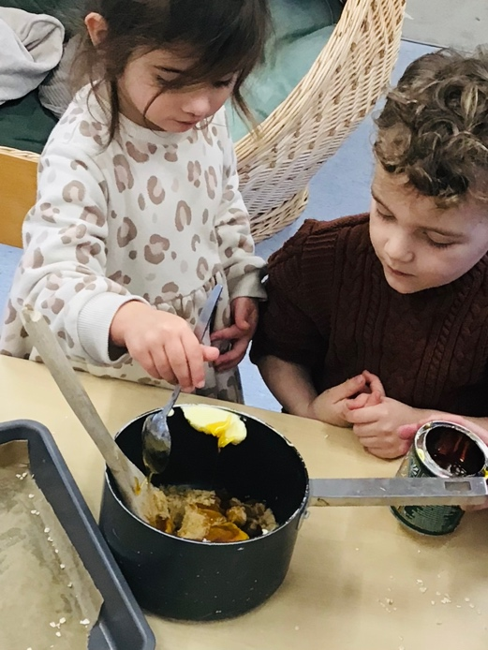

*Building houses for the dolls and make believe birthday parties!*

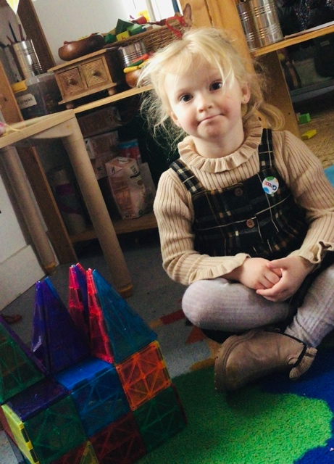 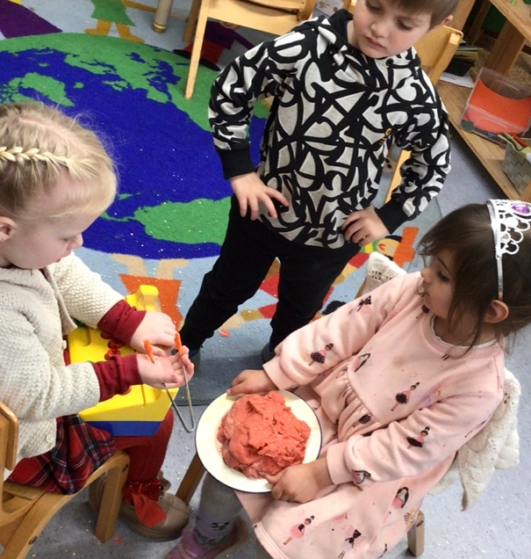

***Timetable***

Make It Monday



Introducing our key text for the week… The Gingerbread Man

Retelling and mapping the story.

Thinking about different words to describe the characters.

Listening games.

Maths games – Counting buttons on the gingerbread men, repeating patterns, measuring different gingerbread people.

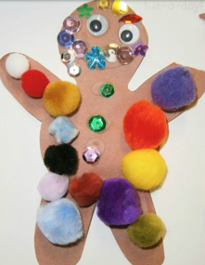Tinkering Tuesday

Design and make a trap to catch the Gingerbread Man.

Creating a map of the Gingerbread Man’s journey from the oven to the river.

Can the children remember who he met on the way?

Exploring the craft resources to decorate our own gingerbread people.

Welly Walk Wednesday & PE with Mr Murnane

On Wednesday we will continue to make our miniature obstacle course ready for Sam’s hamster Bear’s visit. If the children have any junk modelling items that they would like to bring in we can add these to our ‘soft play maze’ so that Bear has a really fun visit!

Gathering a collection of woodland natural materials, such as leaves, twigs, petals and conkers together and using magnifying glasses for children to investigate and describe the materials.

Games we will play at school, which you may enjoy too:

* A game of tag! Encouraging the children to be the Gingerbread Man and avoid obstacles and each other as they try and avoid being caught!
* ‘Run, run as fast as you can, you can’t catch me I’m the Gingerbread Man!’ (Changing the movements e.g., to ‘Skip, skip as fast as you can…’ hop, jump, walk, etc.)

Thinking Thursday

Baking: Designing, making and decorating gingerbread men.

Science experiments:

1. Swimming gingerbread men - Floating and sinking.
2. Gingerbread men in puddles - Changes over time (dissolving in different liquids).
3. Growing ginger - Planting ginger in compost and observing it grow (over the next couple of weeks).

Creating a map of the Gingerbread Man’s journey from the oven to the river. Can the children remember who he met on the way?

Fresh Air Friday

* Gingerbread Man hunt!
* Water play – Creating rivers and waterfalls.
* Mud kitchen - Creating a bakery.

**Dates for the Diary**



* Parent Consultations: Tuesday 11th February 2025 and Wednesday 12th February 2025.
* Toddler Group – LOVE: Friday 14th February 2025, 9.00 – 11.00.
* February Half Term: 17th February 2025 - 21st February 2025.
* Shrove Tuesday - Pancake Races: 4th March 2025, 2.45 – 3.15.
* School Cross Country: Wednesday 6th February 2025 (early finish/pick up).
* Toddler Group – Colours, Love and Spring (Holi): Friday 4th March 2025.
* School Cross Country: Wednesday 19th March 2025 (early finish/pick up).
* Toddler Group – Easter & GRAND EGG HUNT: Friday 4th April 2025.
* Last Day of Spring Term: Friday 4th April 2025.
* Summer Term Begins/Return To School: Tuesday 22nd April 2025.
* PRE-SCHOOL CLOSED: Friday 13th June 2025. Please speak to Jemma about changing your session for this date, should you wish to. Thank you.

**********************************************************************************

**Contact Details**

Stockland Victory Hall, Stockland, Devon EX14 9EF. Phone: 01404 881450

[info@stocklandpreschool.co.uk](mailto:info@stocklandpreschool.co.uk)

**Safeguarding**

If you have any safeguarding concerns, please email [jemma@stocklandpreschool.co.uk](mailto:jemma@stocklandpreschool.co.uk). This inbox is monitored daily. Our Designated Safeguarding Lead is Jemma Harvey-Jones and our Deputy Designated Safeguarding Leads are Kelly Patch and Alice Hutter. Our Child Protection and Safeguarding Policy can be found online at: <https://stocklandpreschool.co.uk/policies-and-procedures/safeguarding>. If you have any concerns about the safety of a child you can either talk to our DSL or DDSL or you can phone Devon MASH on 01392 384964.

**CORE COMMITTEE**

Christina Leppard - Committee Chair [chair@stocklandpreschool.co.uk](mailto:chair@stocklandpreschool.co.uk)

Pippa Salter – Vice Chair, Secretary and Safeguarding [vicechair@stocklandpreschool.co.uk](mailto:vicechair@stocklandpreschool.co.uk)

Emily Foxwell – Treasurer [treasurer@stocklandpreschool.co.uk](mailto:treasurer@stocklandpreschool.co.uk)

**STAFF**

Jemma Harvey-Jones – Manager, SENDCo and DSL [jemma@stocklandpreschool.co.uk](mailto:jemma@stocklandpreschool.co.uk)

Sam Steward - Deputy Manager [sam.s@stocklandpreschool.co.uk](mailto:sam.s@stocklandpreschool.co.uk)

Kelly Patch - Deputy Safeguarding Lead [kelly.p@stocklandpreschool.co.uk](mailto:kelly.p@stocklandpreschool.co.uk)

*To contact any other members of our team please email the* [*info@stocklandpreschool.co.uk*](mailto:info@stocklandpreschool.co.uk) *account and your queries will be forwarded appropriately.*